SQL Project
Sales Data Analysis

- Total sales
SELECT sum(sales) AS Total_Sales
FROM Sales_data
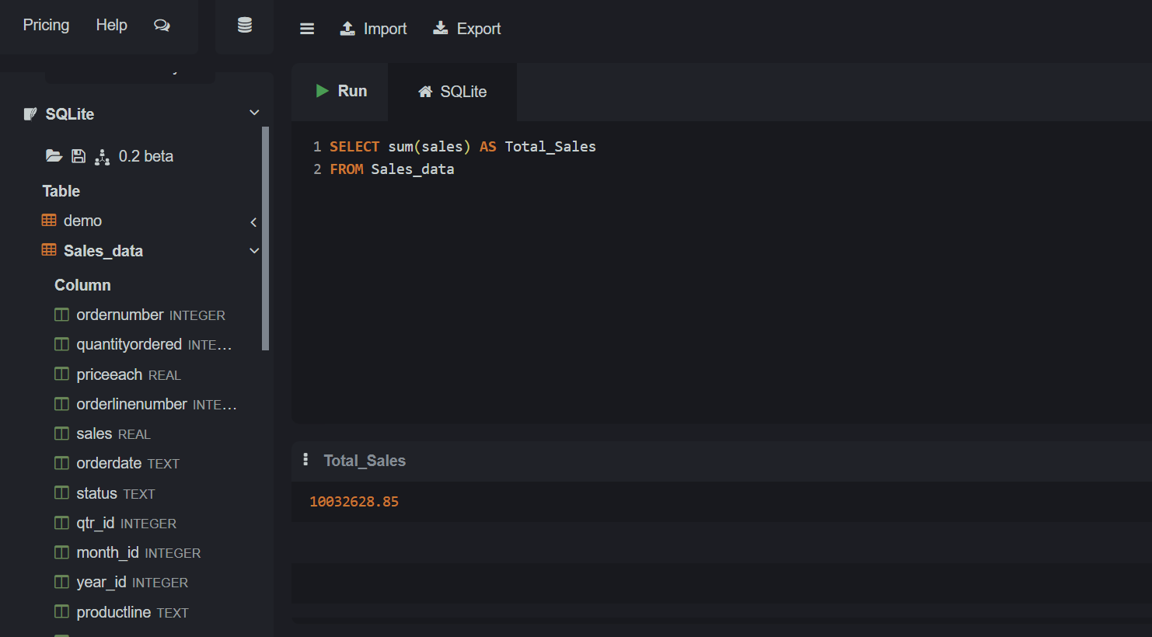

- Top Customers
SELECT customername,
sum(sales) as Total_sales
from Sales_data
GROUP by customername
order by Total_sales DESC
Limit 5;
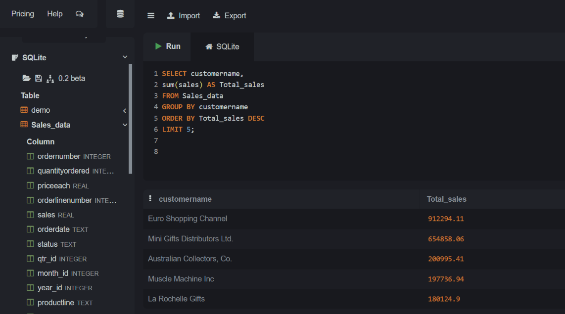
- Country-wise Sales
SELECT country,
sum(sales) as Total_Sales
from Sales_data
group by country
order by Total_Sales DESC;
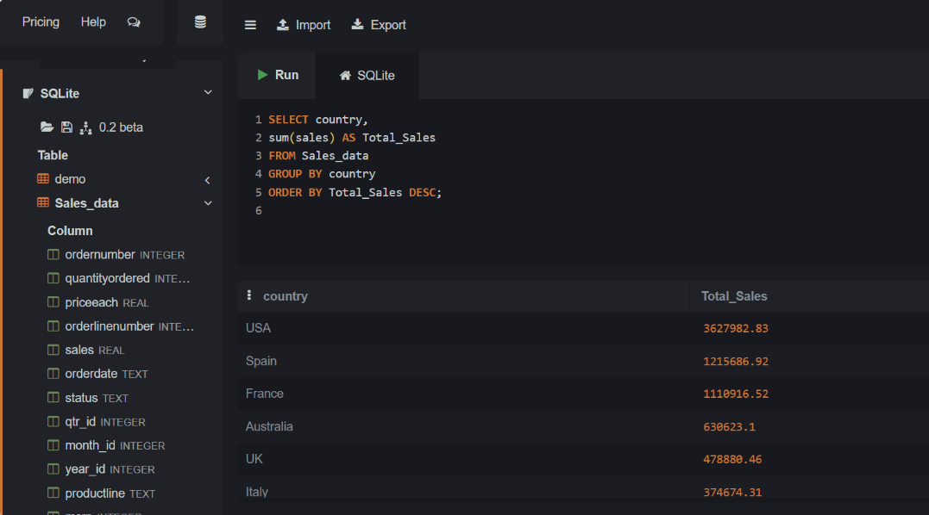

- Monthly Sales Trend
select month_id,
sum(sales) as Total_Sales
from Sales_data
group by month_id
order BY month_id
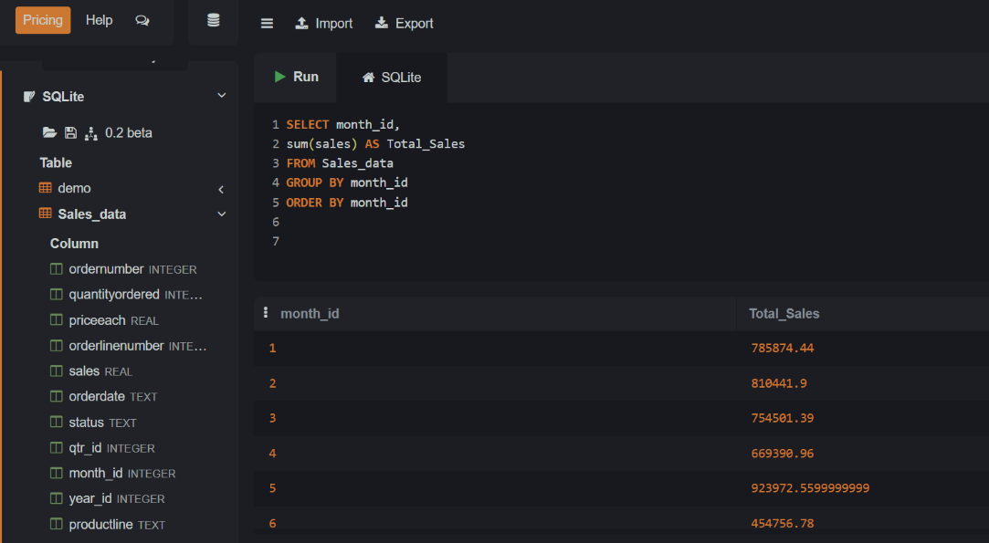

- High / Medium / Low Value Orders
select
case
when sales > 10000 then 'High Value'
when sales > 5000 then 'Medium Value'
when sales >= 1000 then 'Low Value'
ELSE 'Lowest value'
end as Order_Catagory,
count(*) as Total_Orders,
sum(sales) as Total_Sales
FROM Sales_data
GROUP by Order_Catagory;
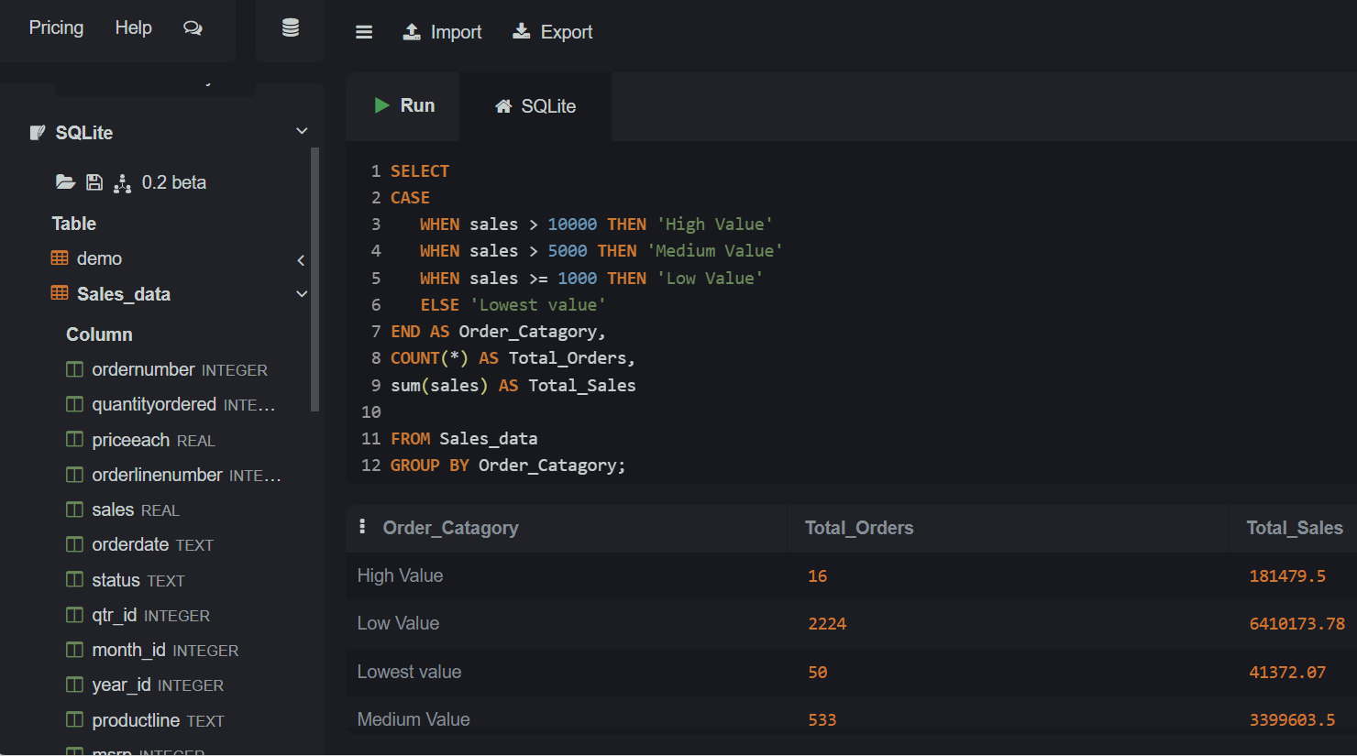

- Customers Purchased More Than Once
select customername, COUNT (*) AS Number_of_Orders
FROM Sales_data
group by customername
having COUNT(*) > 1
order by Number_of_Orders DESC;
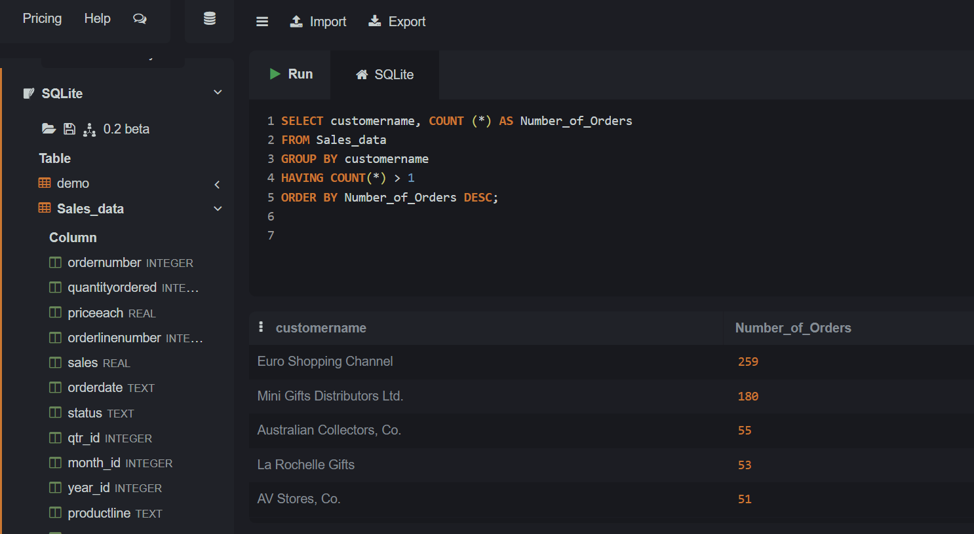
- Best Product Line per Country
select productline, country, sum(sales) as Total_Sales
from Sales_data
group by productline, country
order by country, Total_Sales DESC;
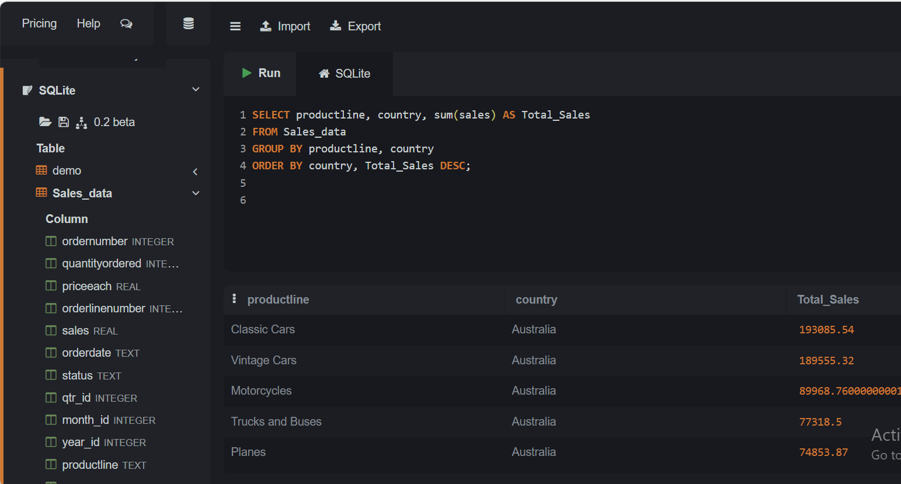

- Country with Most Orders
select country, count(*) as Total_Orders
from Sales_data
GROUP by country
order by Total_Orders DESC
limit 5;
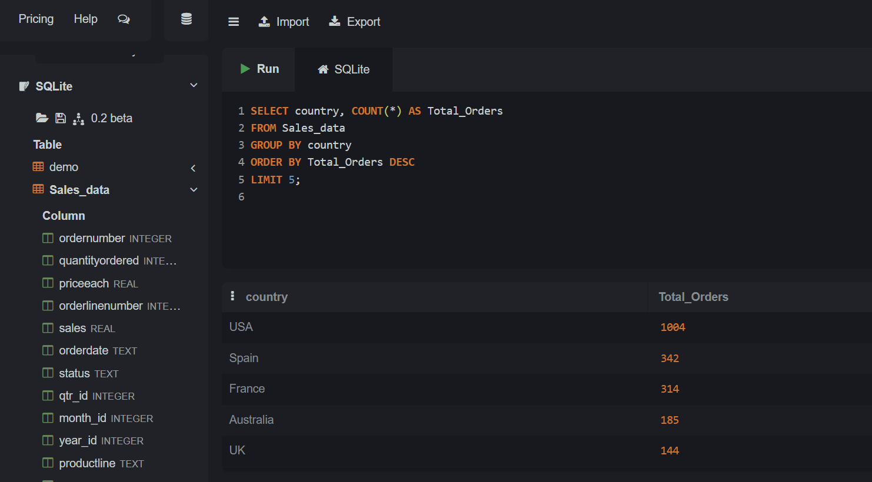
- Average Sales per Order
SELECT Avg(sales)
from Sales_data
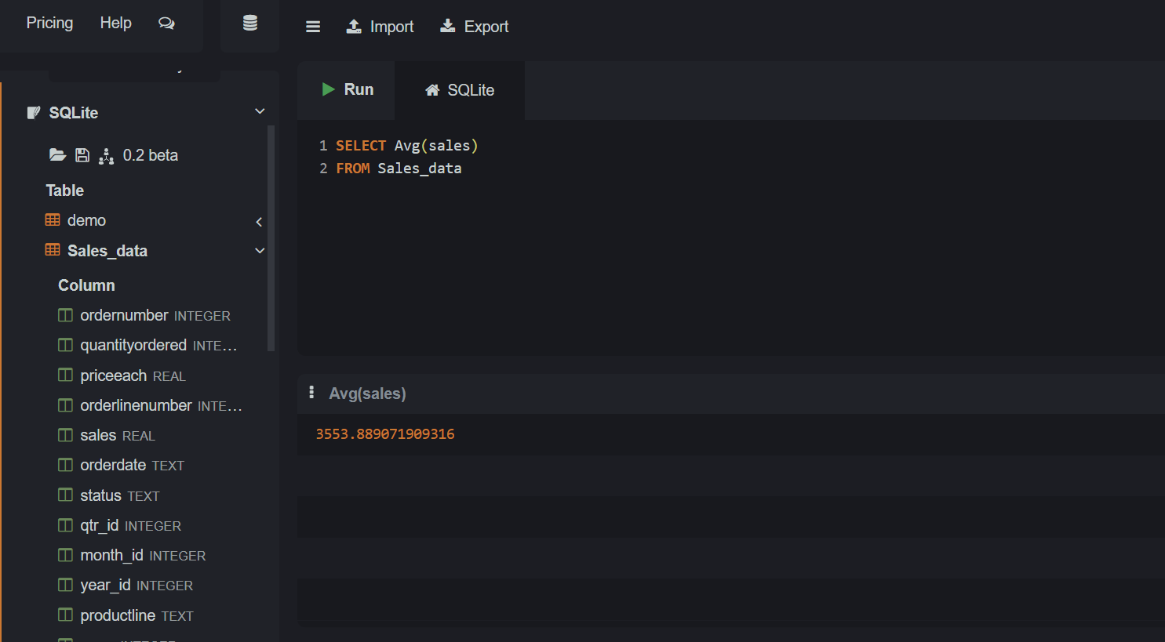

- Month which performed best
select
substr(orderdate, -9, 4) || '-' ||
printf('%02d', CAST(substr(orderdate, 1, instr(orderdate, '/') - 1) as INTIGER))
as month,
sum(sales) as Total_sales
from sales_data
group by month
order by Total_sales DESC;
